# “COSY AIR-CONDITIONERS”

# “LG”

# “Models”

**“126SQ ”**

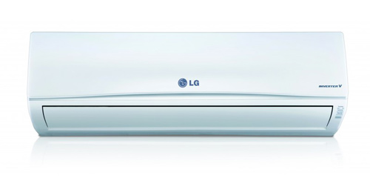

**FEATURES**

* Tropical Compressor 58°C
* Jet Cool
* Jet dry
* Corrosion Resistance
* Volt Care (HVS+LVS)
* Multi protection Filter
* 60% Energy Saving
* Dual Protection Filter
* Optimized Air Flow
* Auto Cleaning
* Absolute Silence 20db
* Quick & Easy Installation
* 1 Ton
* **RS ~ 69000.**

**“186SQ”**



**FEATURES**

* Tropical Compressor 58°C
* Jet Cool
* Jet dry
* Corrosion Resistance
* Volt Care (HVS+LVS)
* Multi protection Filter
* 60% Energy Saving
* Dual Protection Filter
* Optimized Air Flow
* Auto Cleaning
* Absolute Silence 20db
* Quick & Easy Installation
* 1.5 Ton
* **RS ~ 86,000.**

**“246SQ”**



**FEATURES**

* Tropical Compressor 58°C
* Jet Cool
* Jet dry
* Corrosion Resistance
* Volt Care (HVS+LVS)
* Multi protection Filter
* 60% Energy Saving
* Dual Protection Filter
* Optimized Air Flow
* Auto Cleaning
* Absolute Silence 20db
* Quick & Easy Installation
* 2 Ton
* **RS ~ 110,000.**

**“LG S-186 HC”**

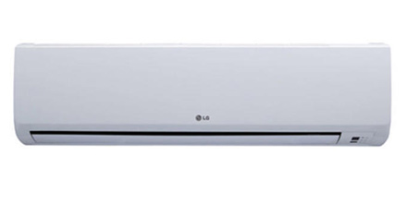

**FEATURES**

* Tropical Compressor 58°C
* Jet Cool
* Jet dry
* Corrosion Resistance
* Capacity - 1.5 Tons
* Cooling Capacity - 6300 W
* Operating Current - 6.8 Amp
* Power Consumption - 1470 W
* 1.5 Ton
* **RS ~ 49,000.**

**“LG Jet Cool S126 DC”**

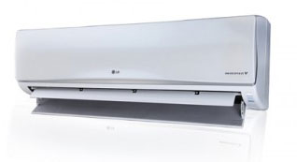

**FEATURES**

* Tropical Compressor (T3) 58 C
* Jet Cool
* MF condenser
* Energy Saver
* Chaos Wind
* Auto Cleaning
* Sleep Mode Auto Operation
* Auto Restart
* 1 Ton
* **RS ~ 47,500.**

**“LG Jet Cool S186 DC”**



**FEATURES**

* Tropical Compressor (T3) 58 C
* Jet Cool
* MF condenser
* Energy Saver
* Chaos Wind
* Auto Cleaning
* Sleep Mode Auto Operation
* Auto Restart
* 1.5 Ton
* **RS ~ 55,000.**

**“LG Jet Cool S246 DC”**



**FEATURES**

* Tropical Compressor (T3) 58 C
* Jet Cool
* MF condenser
* Energy Saver
* Chaos Wind
* Auto Cleaning
* Sleep Mode Auto Operation
* Auto Restart
* 2 Ton
* **RS ~ 74,000.**